BABU BANARASI DAS
UNIVERSITY

2026-2027

SCHOOL OF COMPUTER APPLICATIONS

NoSQL Project On
IPL Player Management in MongoDB

Submitted to: Submitted by :
Mr. Harendra Singh Rishu Singh
BCA(DS&AI)22
1250258363

ACKNOWLEDGEMENT
I sincerely express my gratitude to my teacher Mr. Harendra Singh for giving me the opportunity to work on this NoSQL project titled “IPL Player Management System Using MongoDB”.
This project helped me understand the basic concepts of NoSQL databases and learn how MongoDB is used to create, retrieve, update, sort and delete data. I also learned how different query operators such as greater than, less than, equal to, AND, and OR are used in MongoDB.
I am thankful to my teacher for the guidance and support provided throughout the completion of this project.

INTRODUCTION
MongoDB is a popular NoSQL database management system that stores data in the form of documents. Unlike traditional relational databases, MongoDB does not require data to be stored in fixed rows and columns.
In this project, an IPL Player Management System has been created using MongoDB. The database contains information about 50 IPL players, including their player ID, name, age, runs, and team.
Different MongoDB operations have been performed on the player data, such as inserting, displaying, updating, deleting, sorting, counting, and searching records. Comparison operators such as $eq, $gt, $lt, $gte, and $lte have also been demonstrated.

OBJECTIVES
• To understand the concept of NoSQL databases.
• To learn the basic features of MongoDB.
• To create a database and collection.
• To insert 50 IPL player records.
• To perform CRUD operations.
• To use comparison operators.
• To perform sorting and filtering.
• To understand AND and OR operations.

1. CREATE DATABASE
MongoDB Query:
use IPL
Explanation: Creates or switches to the IPL database.
Output Screenshot:
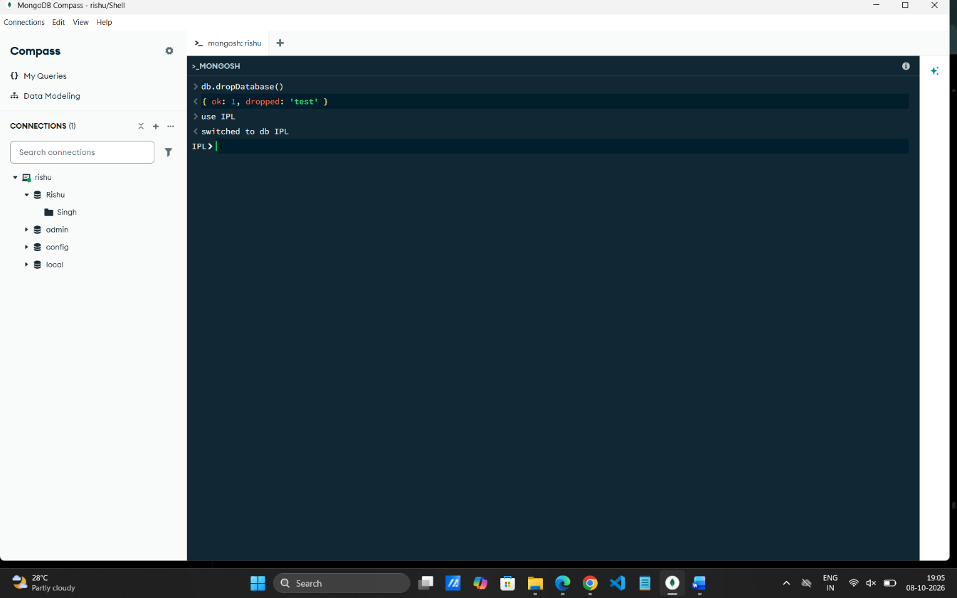

2. CREATE COLLECTION
MongoDB Query:
db.createCollection("players")
Explanation: Creates a collection named players.
Output Screenshot:
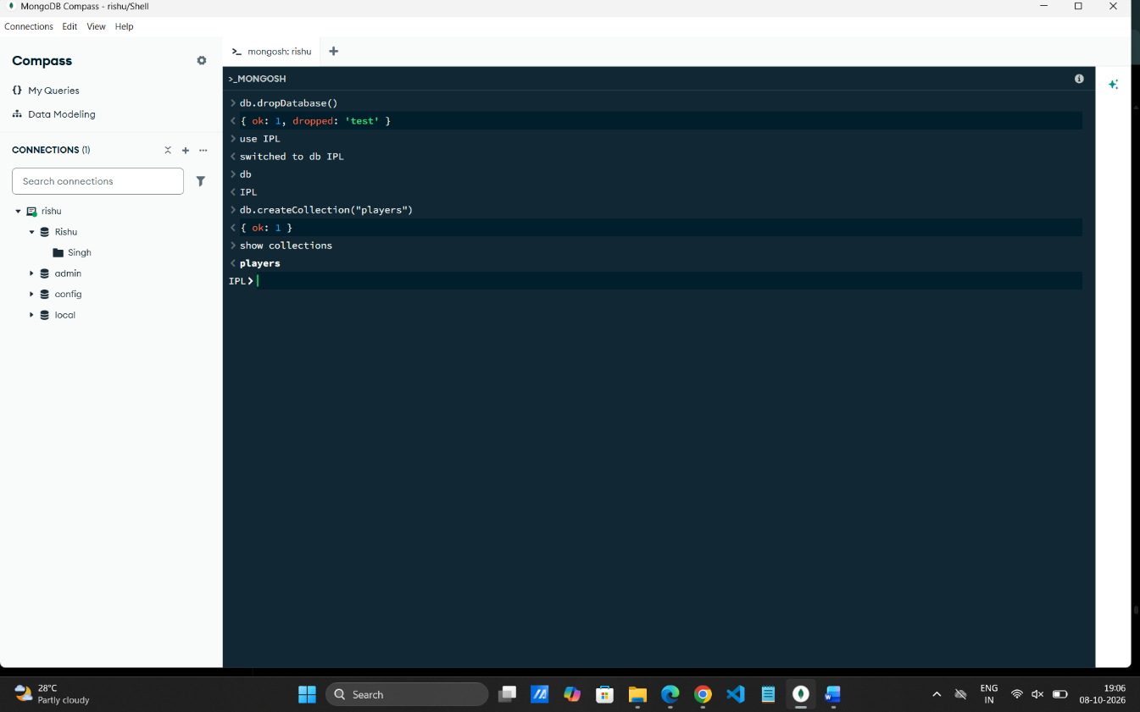

3. INSERT 50 IPL PLAYERS
MongoDB Query:
db.players.insertMany([
{playerId:1, name:"Virat Kohli", age:37, runs:650, team:"RCB"},
{playerId:2, name:"Rajat Patidar", age:32, runs:480, team:"RCB"},
{playerId:3, name:"Yash Dayal", age:28, runs:25, team:"RCB"},
{playerId:4, name:"Phil Salt", age:29, runs:620, team:"RCB"},
{playerId:5, name:"Jitesh Sharma", age:32, runs:310, team:"RCB"},
{playerId:6, name:"Ruturaj Gaikwad", age:29, runs:590, team:"CSK"},
{playerId:7, name:"MS Dhoni", age:45, runs:280, team:"CSK"},
{playerId:8, name:"Ravindra Jadeja", age:37, runs:320, team:"CSK"},
{playerId:9, name:"Shivam Dube", age:33, runs:410, team:"CSK"},
{playerId:10, name:"Matheesha Pathirana", age:23, runs:18, team:"CSK"},
{playerId:11, name:"Rohit Sharma", age:39, runs:510, team:"MI"},
{playerId:12, name:"Suryakumar Yadav", age:36, runs:620, team:"MI"},
{playerId:13, name:"Hardik Pandya", age:33, runs:390, team:"MI"},
{playerId:14, name:"Jasprit Bumrah", age:32, runs:30, team:"MI"},
{playerId:15, name:"Tilak Varma", age:23, runs:550, team:"MI"},
{playerId:16, name:"Shubman Gill", age:26, runs:920, team:"GT"},
{playerId:17, name:"Sai Sudharsan", age:24, runs:830, team:"GT"},
{playerId:18, name:"Rashid Khan", age:27, runs:210, team:"GT"},
{playerId:19, name:"Mohammed Siraj", age:32, runs:35, team:"GT"},
{playerId:20, name:"Shahrukh Khan", age:30, runs:260, team:"GT"},
{playerId:21, name:"Sanju Samson", age:31, runs:570, team:"RR"},
{playerId:22, name:"Yashasvi Jaiswal", age:24, runs:610, team:"RR"},
{playerId:23, name:"Riyan Parag", age:25, runs:450, team:"RR"},
{playerId:24, name:"Dhruv Jurel", age:25, runs:330, team:"RR"},
{playerId:25, name:"Trent Boult", age:37, runs:45, team:"RR"},
{playerId:26, name:"Shreyas Iyer", age:31, runs:575, team:"PBKS"},
{playerId:27, name:"Arshdeep Singh", age:27, runs:40, team:"PBKS"},
{playerId:28, name:"Prabhsimran Singh", age:25, runs:360, team:"PBKS"},
{playerId:29, name:"Liam Livingstone", age:33, runs:300, team:"PBKS"},
{playerId:30, name:"Yuzvendra Chahal", age:36, runs:35, team:"PBKS"},
{playerId:31, name:"KL Rahul", age:34, runs:520, team:"DC"},
{playerId:32, name:"Rishabh Pant", age:29, runs:440, team:"DC"},
{playerId:33, name:"Axar Patel", age:32, runs:350, team:"DC"},
{playerId:34, name:"Kuldeep Yadav", age:31, runs:28, team:"DC"},
{playerId:35, name:"Mukesh Kumar", age:32, runs:20, team:"DC"},
{playerId:36, name:"Nicholas Pooran", age:30, runs:530, team:"LSG"},
{playerId:37, name:"Mayank Yadav", age:23, runs:15, team:"LSG"},
{playerId:38, name:"Ayush Badoni", age:26, runs:290, team:"LSG"},
{playerId:39, name:"Ravi Bishnoi", age:26, runs:25, team:"LSG"},
{playerId:40, name:"Aiden Markram", age:31, runs:390, team:"LSG"},
{playerId:41, name:"Sunil Narine", age:38, runs:380, team:"KKR"},
{playerId:42, name:"Andre Russell", age:38, runs:310, team:"KKR"},
{playerId:43, name:"Rinku Singh", age:28, runs:420, team:"KKR"},
{playerId:44, name:"Varun Chakravarthy", age:35, runs:22, team:"KKR"},
{playerId:45, name:"Harshit Rana", age:25, runs:35, team:"KKR"},
{playerId:46, name:"Pat Cummins", age:33, runs:190, team:"SRH"},
{playerId:47, name:"Travis Head", age:32, runs:560, team:"SRH"},
{playerId:48, name:"Heinrich Klaasen", age:35, runs:510, team:"SRH"},
{playerId:49, name:"Abhishek Sharma", age:25, runs:590, team:"SRH"},
{playerId:50, name:"Bhuvneshwar Kumar", age:36, runs:30, team:"SRH"}
])
Explanation: Inserts multiple IPL player documents into the collection.
Output Screenshot:
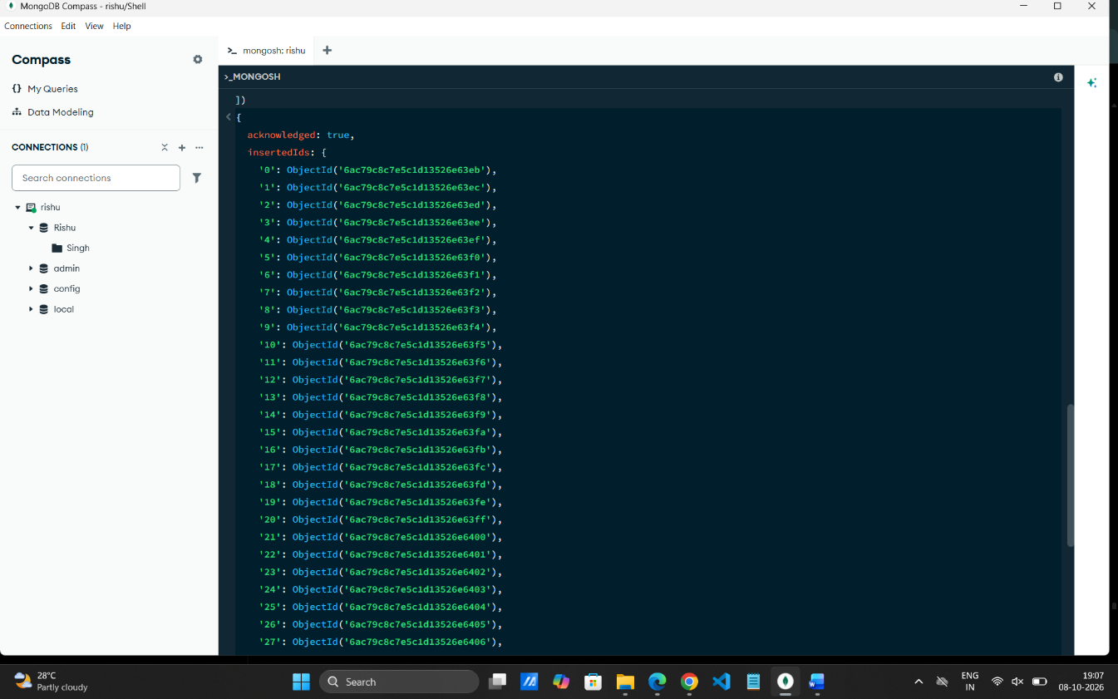

4. DISPLAY ALL IPL PLAYERS
MongoDB Query:
db.players.find()
Explanation: Retrieves all documents from the players collection.
Output Screenshot:
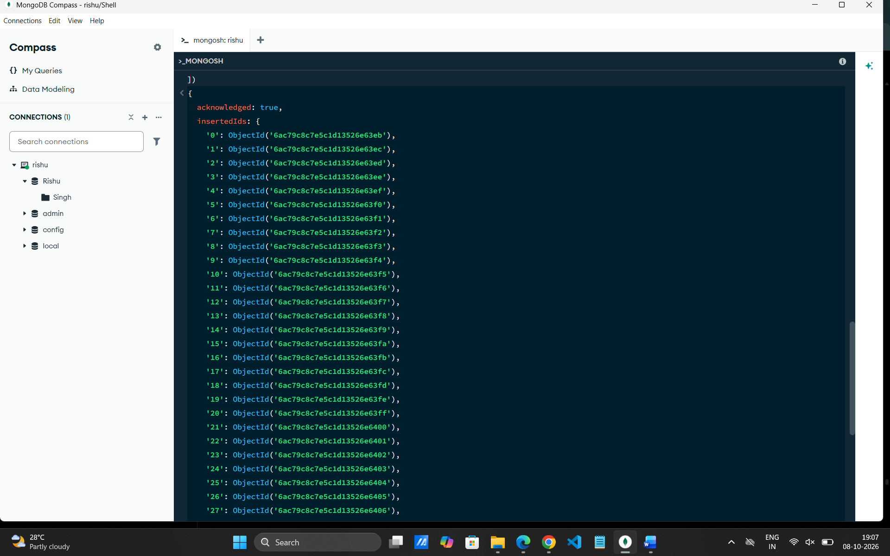

5. EQUAL TO — $eq
MongoDB Query:
db.players.find({runs: {$eq: 620}})
Explanation: Finds players whose runs are exactly 620.
Output Screenshot:
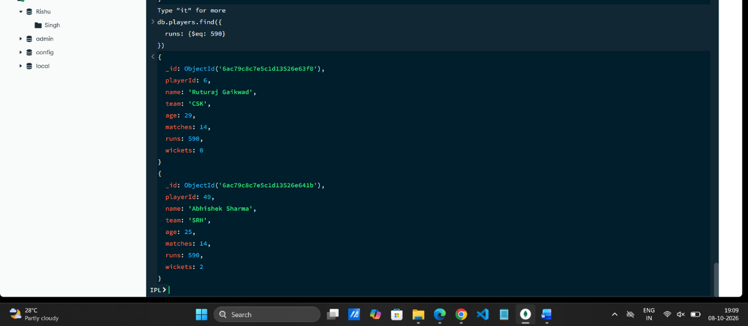

6. GREATER THAN — $gt
MongoDB Query:
db.players.find({runs: {$gt: 500}})
Explanation: Finds players whose runs are greater than 500.
Output Screenshot:
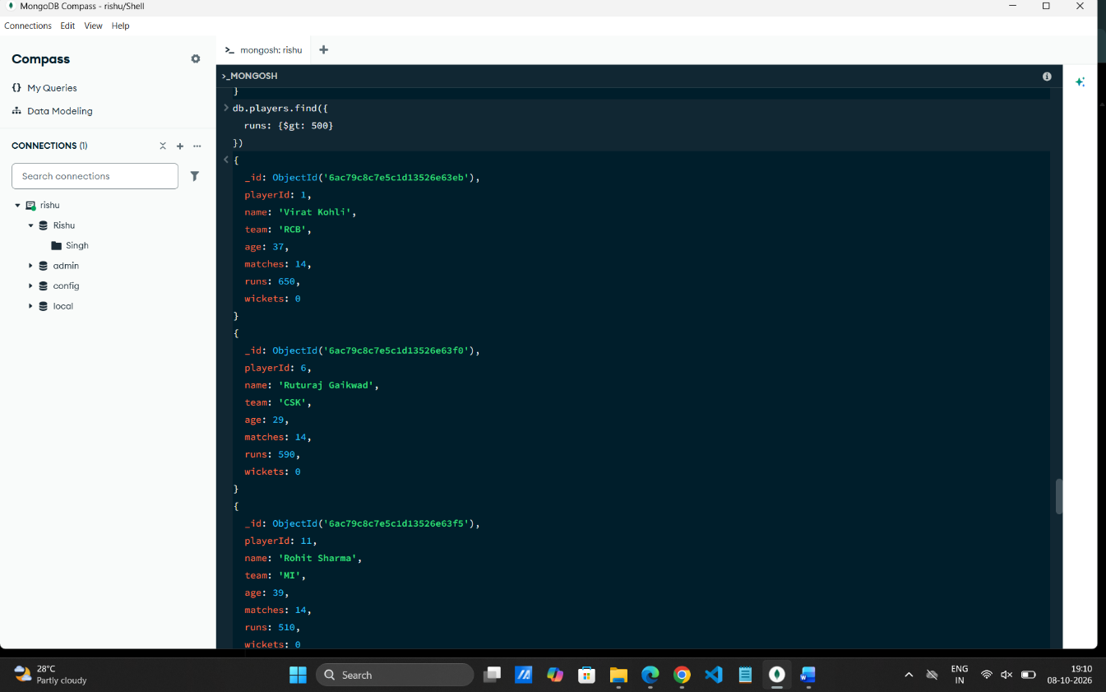

7. LESS THAN — $lt
MongoDB Query:
db.players.find({runs: {$lt: 200}})
Explanation: Finds players whose runs are less than 200.
Output Screenshot:
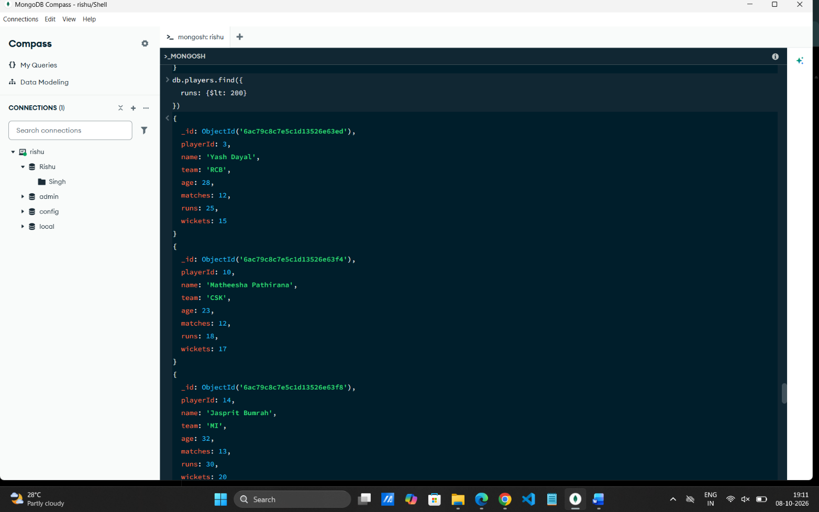

8. GREATER THAN OR EQUAL TO — $gte
MongoDB Query:
db.players.find({runs: {$gte: 600}})
Explanation: Finds players whose runs are 600 or above.
Output Screenshot:
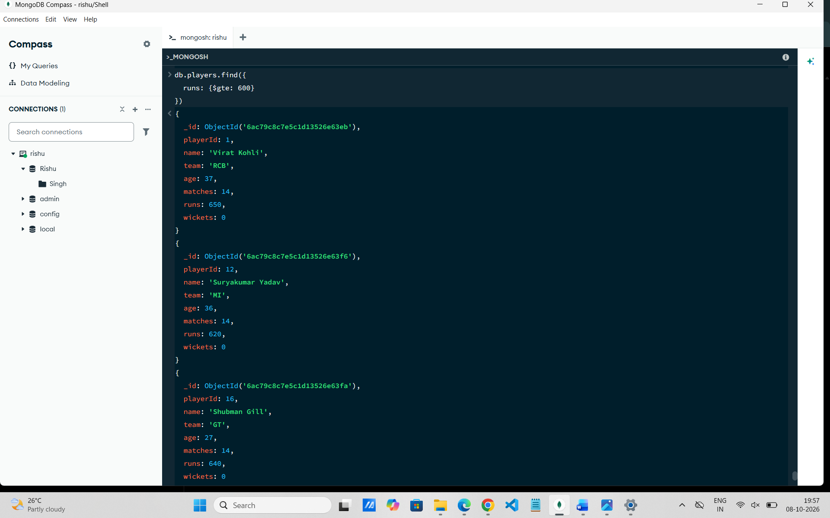

9. LESS THAN OR EQUAL TO — $lte
MongoDB Query:
db.players.find({runs: {$lte: 300}})
Explanation: Finds players whose runs are 300 or below.
Output Screenshot:
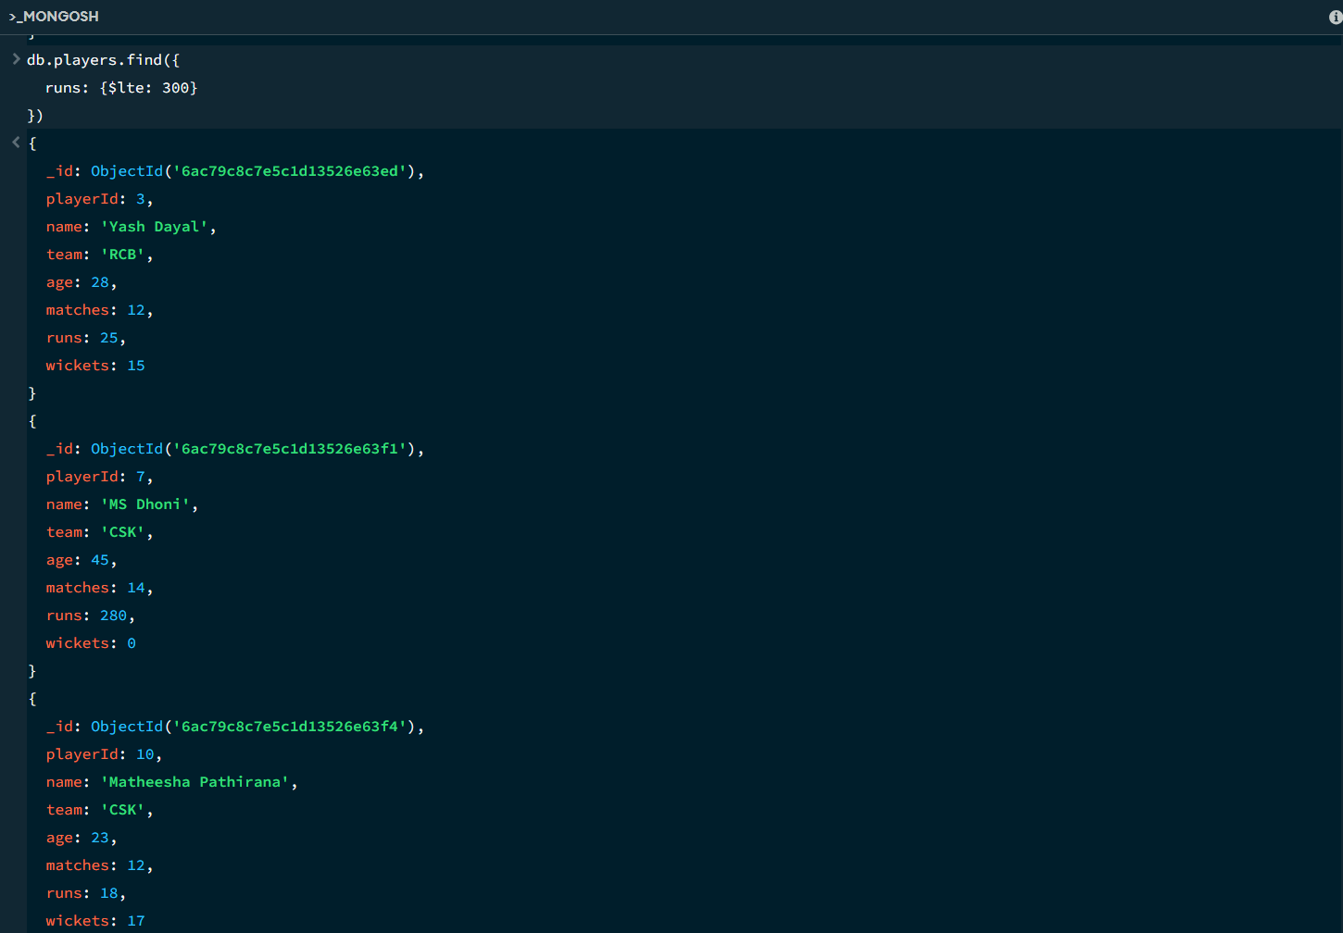

10. UPDATE OPERATION
MongoDB Query:
db.players.updateOne(
{playerId:5},
{$set:{runs:950}}
)
Explanation: Updates the runs to 950 of the player with playerId 5.
Output Screenshot:
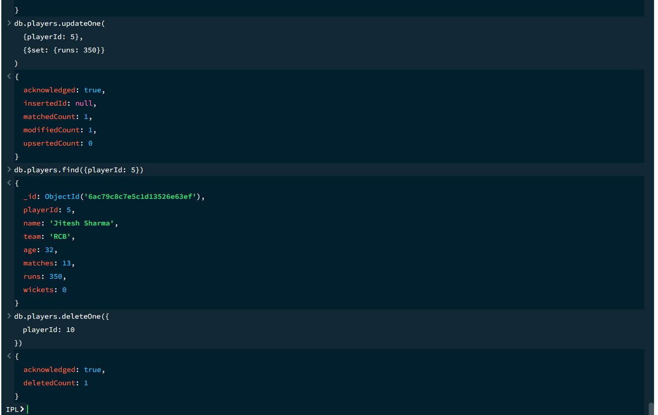

11. DELETE ONE OPERATION
MongoDB Query:
db.players.deleteOne({playerId:10})
Explanation: Deletes one document matching playerId 10.
Output Screenshot:
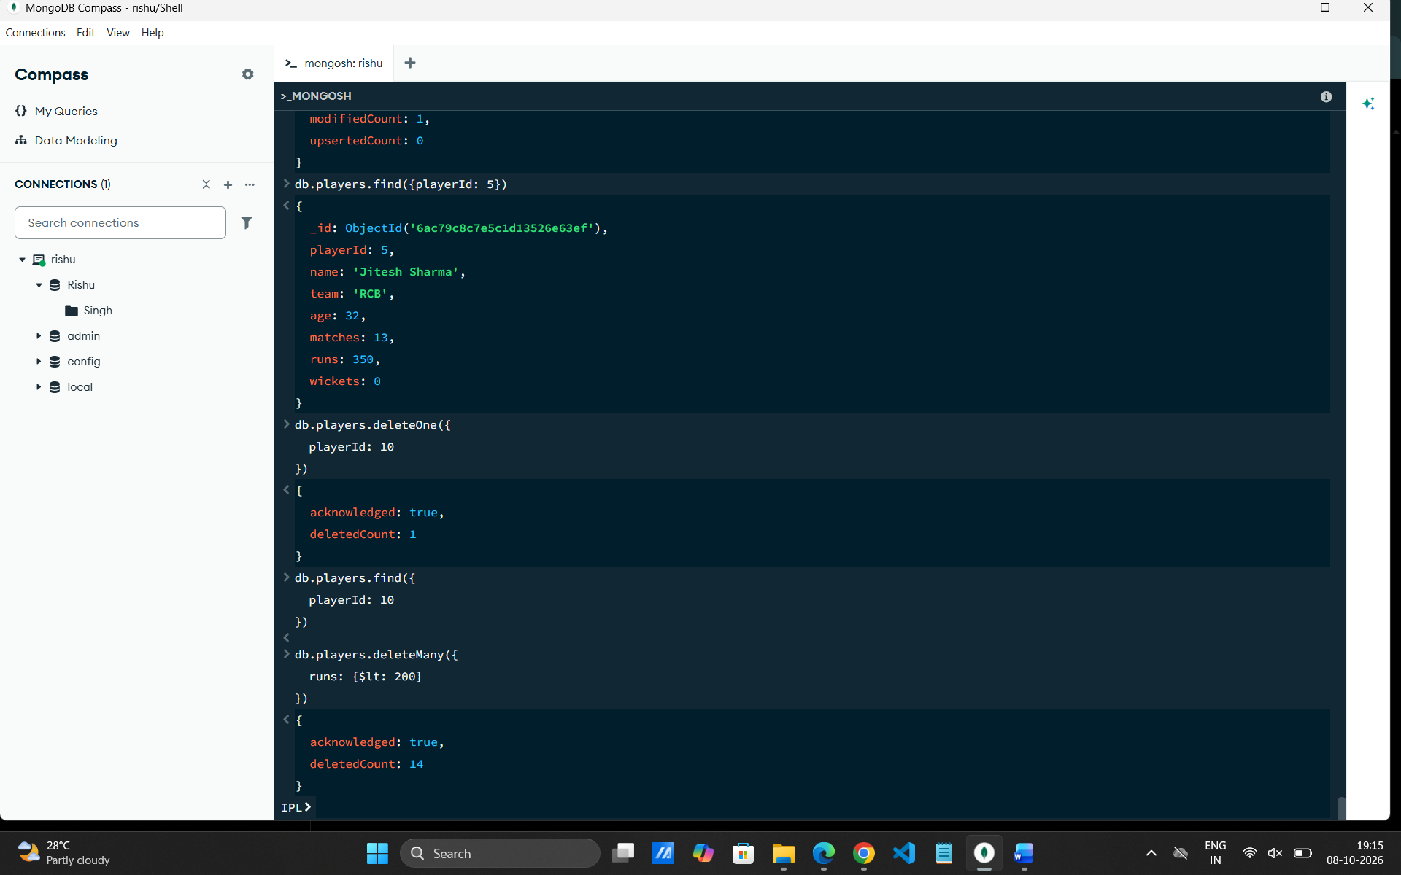

12. DELETE MANY OPERATION
MongoDB Query:
db.players.deleteMany({
runs: {$lt:200}
})
Explanation: Deletes all players having runs below 200
Output Screenshot:

13. AND OPERATION — $and
MongoDB Query:
db.players.find({
$and:[
{runs:{$gt:800}},
{age:26}
]
})
Explanation: Finds IPL players satisfying both conditions.
Output Screenshot:
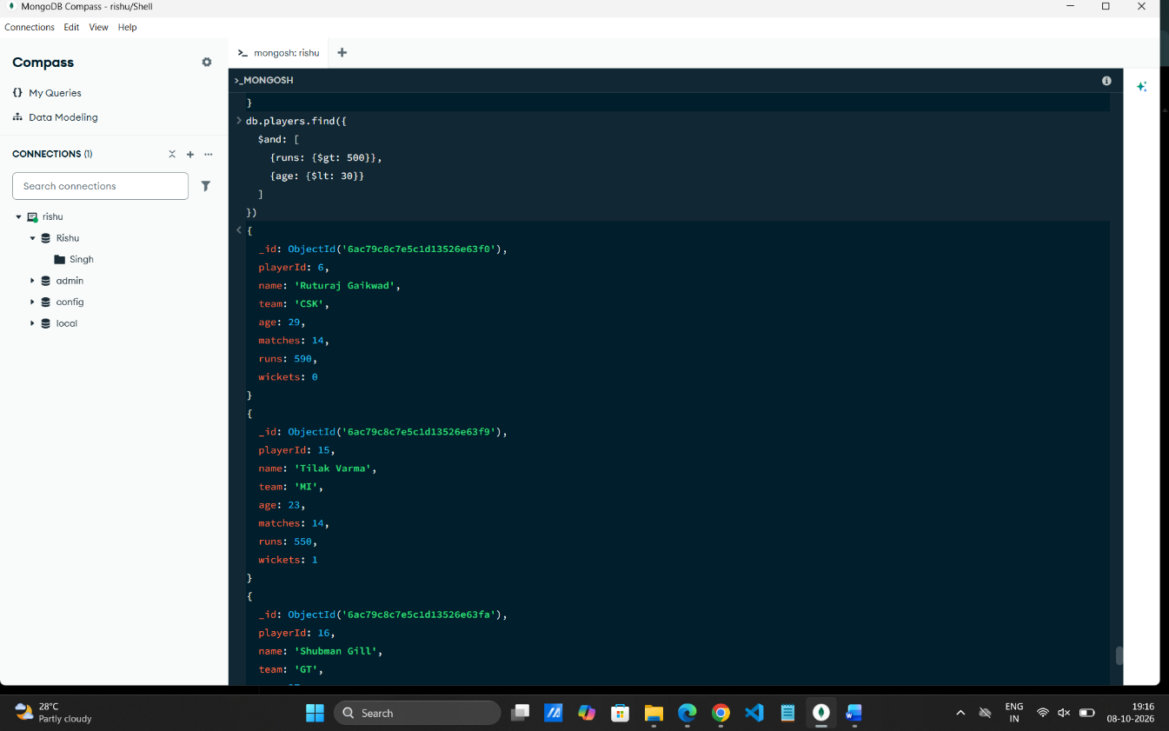

14. OR OPERATION — $or
MongoDB Query:
db.players.find({
$or:[
{team:"RCB"},
{team:"CSK"}
]
})
Explanation: Finds players who belong to the RCB or CSK team.
Output Screenshot:
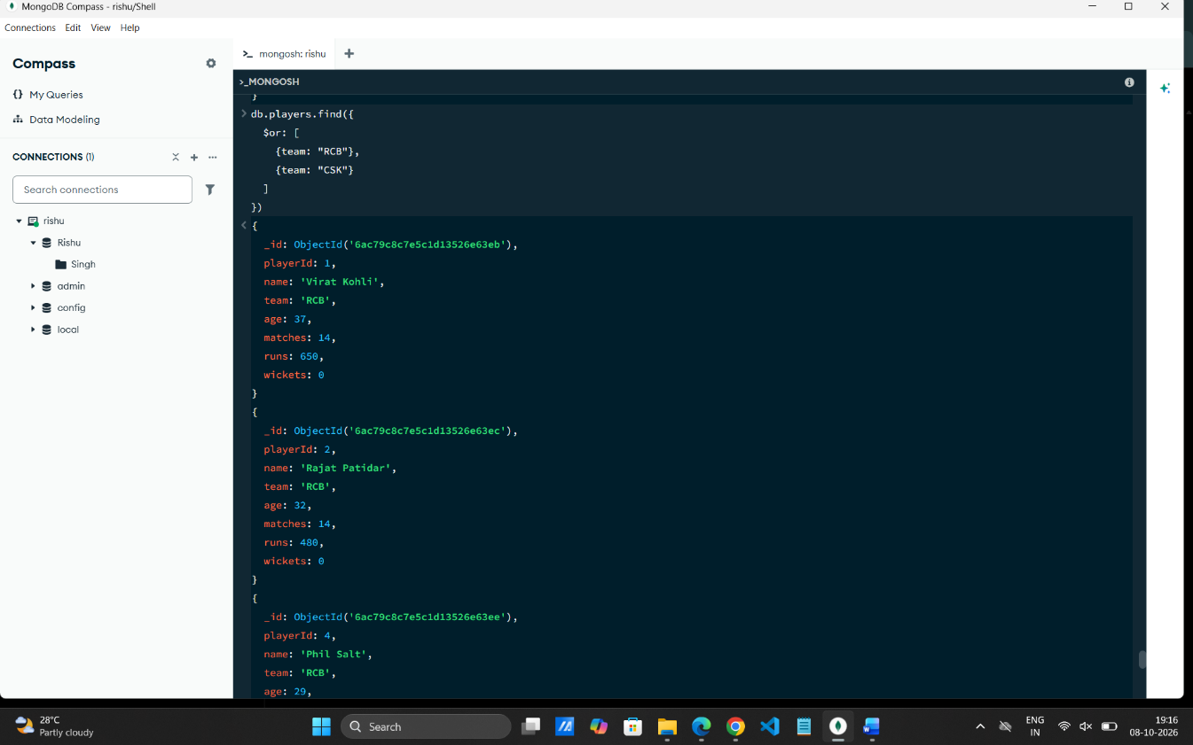

15. SORT OPERATION
A. MongoDB Query:
db.players.find().sort({runs: 1})
Explanation: Sorts players by runs from lowest to highest. Use 1 for ascending order.
Output Screenshot:
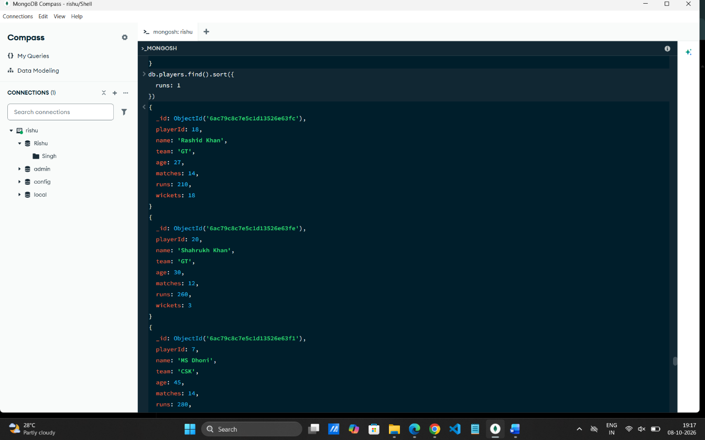

B. MongoDB Query:
db.players.find().sort({runs: -1})
Explanation: Sorts players by runs from highest to lowest. Use -1 for descending order.
Output Screenshot:
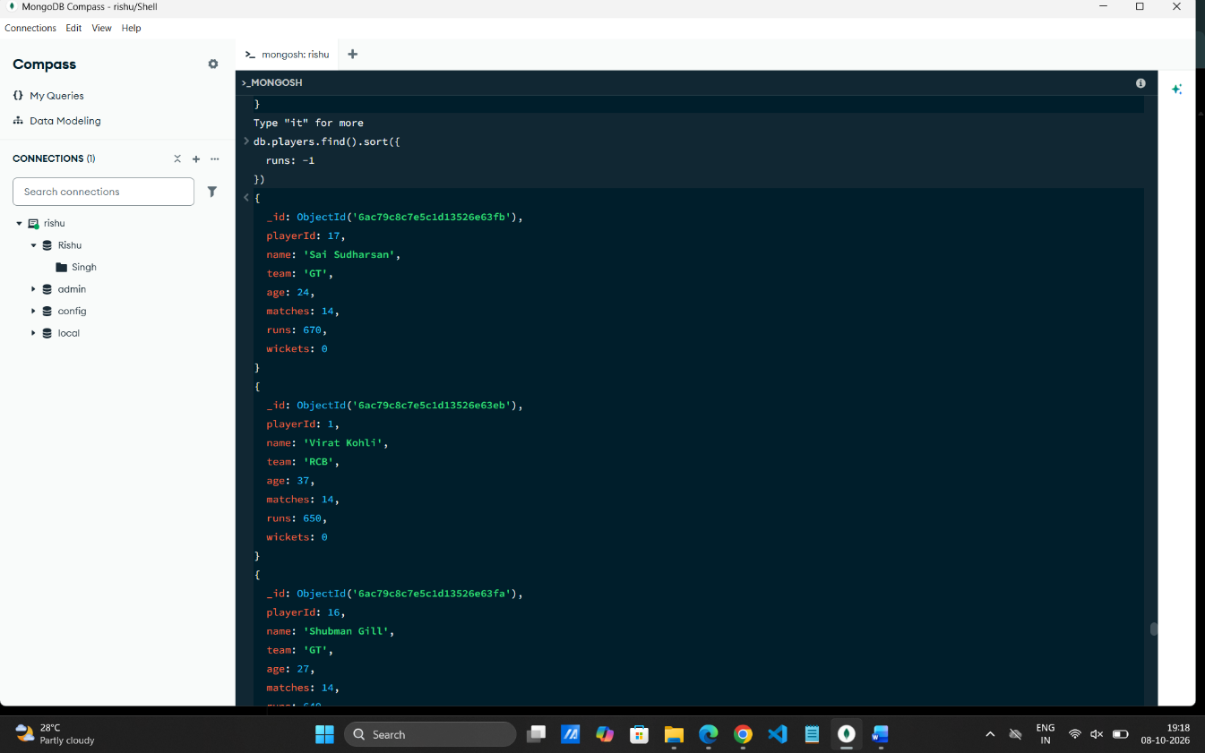

16. LIMIT OPERATION
MongoDB Query:
db.players.find().limit(5)
Explanation: Displays only the first five player documents.
Output Screenshot:
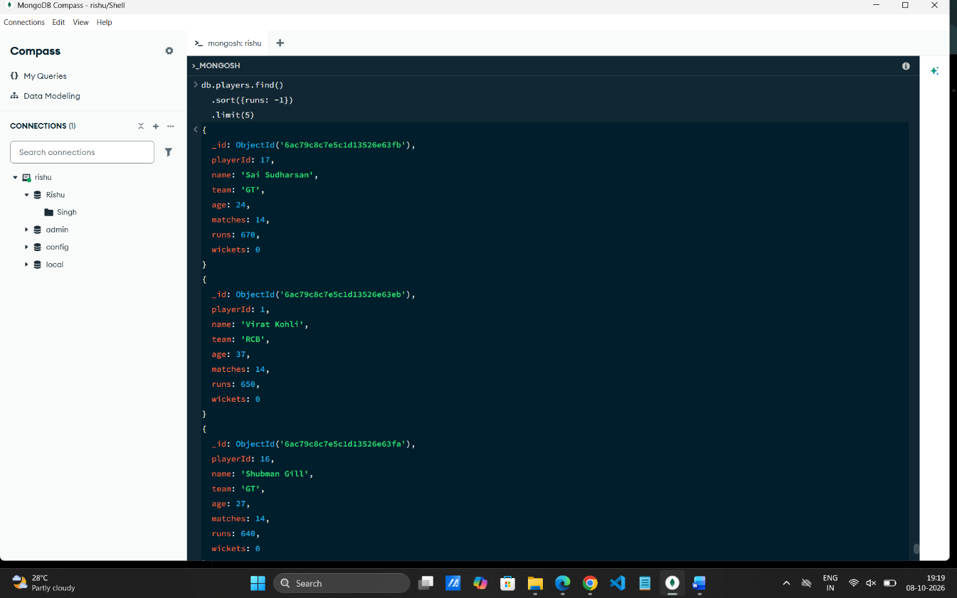

17. SEARCH BY TEAM
MongoDB Query:
db.players.find({team:"RCB"})
Explanation: Finds all players who belong to the RCB team.
Output Screenshot:
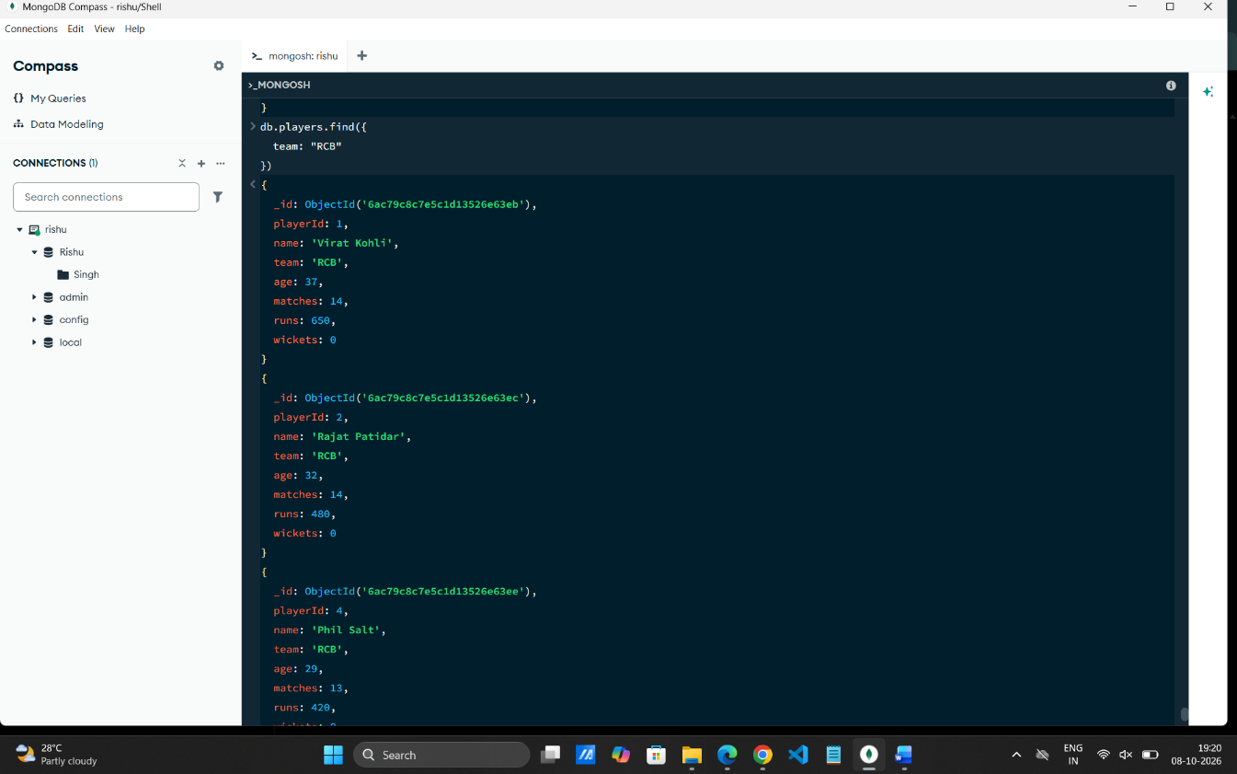

18. COUNT DOCUMENTS
MongoDB Query:
db.players.countDocuments()
Explanation: Counts documents currently present in the collection (performed after the delete operations).
Output Screenshot:
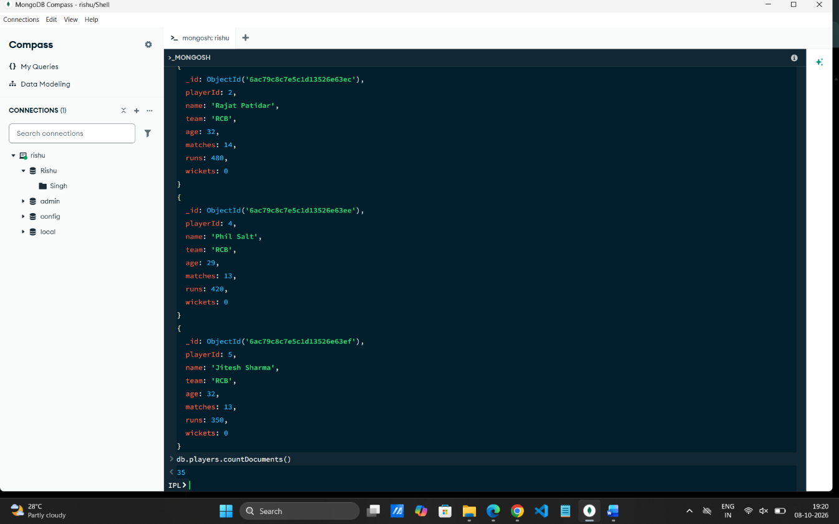

MONGODB OPERATORS USED
Operator | Meaning | Example
$eq | Equal to | runs: {$eq:620}
$gt | Greater than | runs: {$gt:850}
$lt | Less than | runs: {$lt:350}
$gte | Greater than or equal to | runs: {$gte:900}
$lte | Less than or equal to | runs: {$lte:400}
$and | All conditions true | $and:[...]
$or | At least one condition true | $or:[...]

CONCLUSION
This project provided practical knowledge of NoSQL databases using MongoDB. An IPL Player Management System containing player information was created and different MongoDB operations were performed on the data.
Through this project, I learned how to insert, retrieve, update, and delete documents. I also learned how to arrange data in ascending and descending order, how comparison operators such as $eq, $gt, $lt, $gte, and $lte work, along with logical operators such as $and and $or.
Overall, this project helped me understand how MongoDB can be used to manage and query IPL player data efficiently.

